Order Of Lenten Service

Opening Hymn: TLH 143 vs 1-5

Reading: Lent III

The History of the Passion of our Lord

Sermon Hymn: TLH 143 vs 6-10

Sermon Text: Song Of Solomon 5:15a

His Legs

Prayer

Holy Communion

The Lord's Prayer

The Blessing

Closing Hymn: TLH 143 vs 11-15

* * * * * * * * * * * * *

Bible Study: Lambs: A Special Pheasant
Sheep: Proverbs 13:16-20; Your Choice



The Supreme Court

Water
Of
Life

12 March 2017

W A T E R O F L I F E

Worship Service: 9:30 a.m. Bible Study: 10:45 a.m.

Larry Cooper, Pastor E-Mail address:
111 N. Ridge Road lcooper@wateroflife.cc
Coon Valley, WI 54623 Web Site:
Phone: (608) 452-2105 www.wateroflife.cc

* * * * * * * * * * * * * * * * * * * * * * * * * * *

Sermon Text: Song Of Solomon 5:15a

His Legs

* * * * * * * * * * * * * * * * * * * * * * * * * * *

Song of Solomon 5:15a His legs are as pillars of marble, set upon sockets of fine gold.

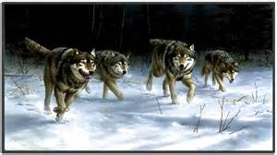
The Legs Feed the Wolf

Hockey fans all over the world marvel at the 1980 Winter Olympics held in Lake Placid, N.Y., when the U.S.A hockey team defeated the heavily favored Russian team, and then went on to defeat Finland to win the gold medal.

The victory over the Russians has been called the Miracle on Ice. Coached by the famous University of Minnesota hockey coach, the late Herb Brooks, a bunch of college kids upset the Soviet Union’s team, at that time the greatest hockey team in the world.

Herb drilled his team especially hard in order to get their legs in shape to play three full periods every game without letting up. His motto to his team was—“The legs feed the wolf, boys!”

The Legs Feed the Lion

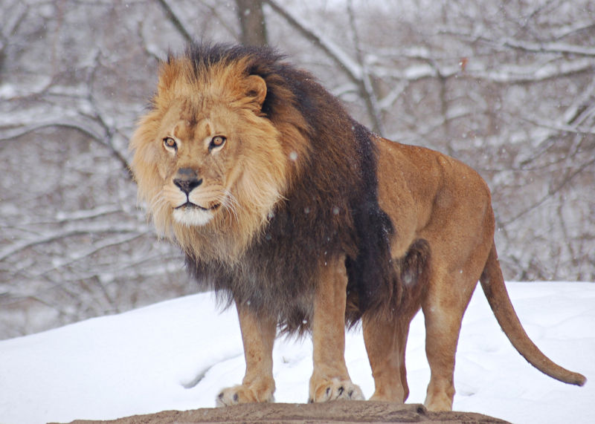

This morning, perhaps we could modify Herb’s saying to—The Legs Feed the Lion! Not only “a” lion. But “The Lion.” The Lion of the Tribe of Judah—Jesus Christ. The picture here would be the Lion Bridegroom protecting his Bride by destroying her enemies. This is yet another illustration of the truth that the salvation of the Bride goes hand in hand with the complete destruction of her enemies.

